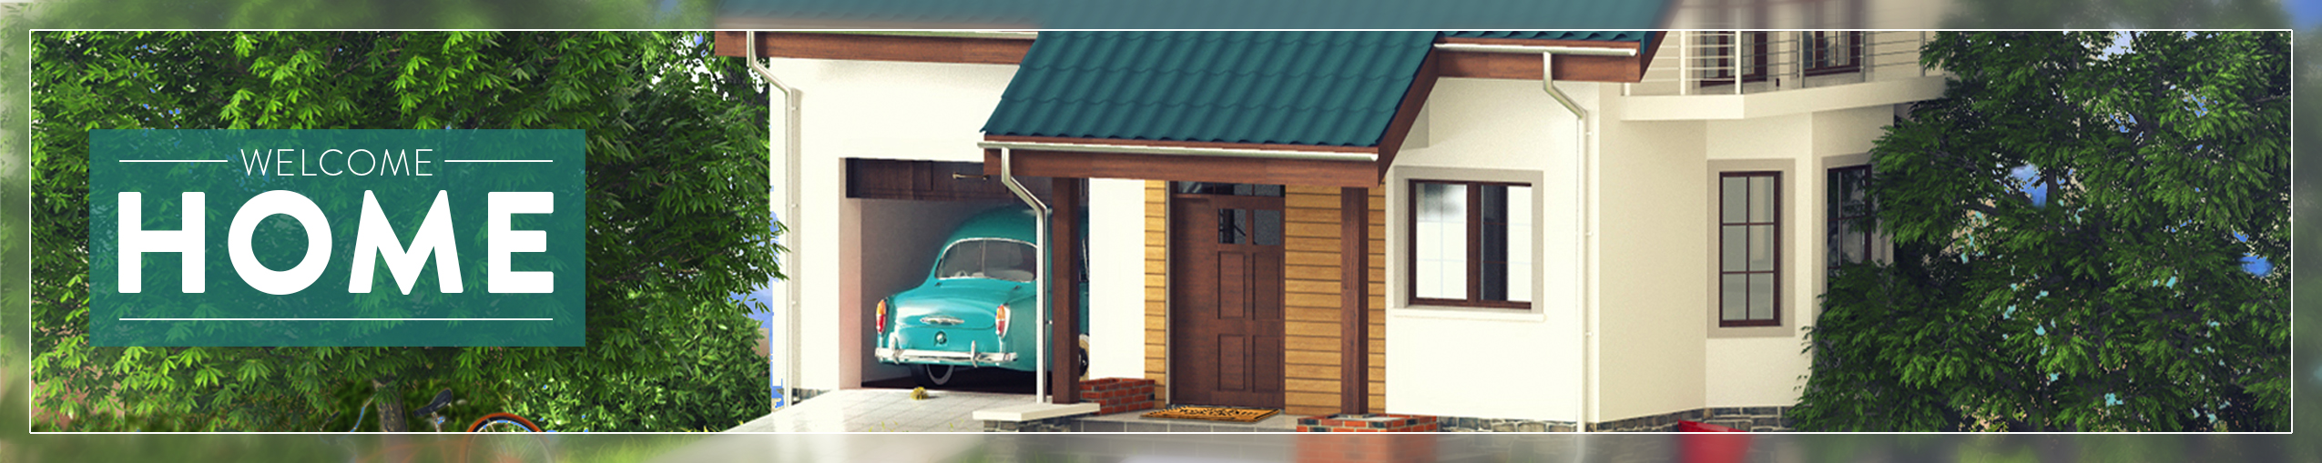

Greetings!

This resource guide will guide you through the Welcome Home resources. If you have additional questions, contact Jason Moore at jason@midnightoilproductions.com. Please allow 24 hours for responses.

What’s included:

RESOURCE GUIDE – READ FIRST.doc:
The Document you’re reading now!

WEEKLY INTRO VIDEO FOLDER:

WELCOME HOME INTRO VIDEO NON-WIDE.MP4
This intro video can be used each week of the series as a setup for the theme. The “non-wide” version should be used in churches with standard definition or 4:3 ration screens.

WELCOME HOME INTRO VIDEO WIDESCREEN.MP4
This intro is identical to the non-wide, except it is widescreen and formatted for churches with hi-definition 16:9 aspect ratio screens.

LOOPING BACKGROUND:

WELCOME HOME LOOP NON-WIDE.MP4
A seamless looping video often used for song lyrics is included. It should be inserted into your presentation program and set to loop. This version is for standard definition 4:3 aspect ration screens.

WELCOME HOME LOOP WIDESCREEN.MP4
This is the hi-definition 16:9 aspect ration loop.

SERIES PROMO MATERIALS

DIRECT MAIL CARD
This folder contains print-ready art, great for promoting the series ahead of time. The at work is laid out as a 4x6” card and may be printed in-house or at a professional printer.

A layered file for advanced customization is included.

FACEBOOK COVER
Use this on your church’s facebook page or on your personal page to promote the series.

WEEK 1 – 6 FOLDERS

BULLETIN COVER
In this folder you’ll find 3 files:
WEEK X –BULLETIN BLACK & WHITE.jpg –
A black and white 8.5x5.5 bulletin cover.
WEEK X –BULLETIN COLOR.jpg –
A color 8.5x5.5 bulletin cover.
WEEK X –BULLETIN LAYERED.psd –
A layered version of the color meant for advanced users who want to
further customize the file. It is in Photoshop format.

NON-WIDESCREEN GRAPHICS
WEEK X – BLANK GRAPHIC.jpg
This is a 4:3 aspect ratio graphic with no text or bars for text in a flattened/non editable format.
WEEK X – METAPHOR NAME.psd
This is a 4:3 aspect ratio graphic with all of the layers present for advanced editing. Be sure and load the font before opening.
WEEK X – POINT GRAPHIC.jpg
This is a 4:3 aspect ratio graphic with the backing bar/box for behind the text, but with no text present on the graphics. Use it for sermon points and custom titles.
WEEK X –SONG GRAPHIC.jpg
This is a 4:3 aspect ratio graphic suitable for large bodies of text like scripture and song lyrics. If not using the loop, this graphic is recommended during worship to maintain the theme.
WEEK X –TITLE GRAPHIC.jpg
This is a 4:3 aspect ratio graphic with the title included. It is not editable.

WEEK X – CREATIVE GUIDE
This file contains written creative elements such as calls to worship, music and movie suggestions and more.

WIDESCREEN GRAPHICS
This folder contains the same options as the widescreen graphics, only HD and widescreen.

